A

SUMMER RESEARCH INTERNSHIP

REPORT ON

# Power Electronics Devices in Transmission Line

DISCIPLINE OF ELECTRICAL ENGINEERING

INDIAN INSTITUTE OF TECHNOLOGY INDORE

JUNE 2024



|  |  |
| --- | --- |
| **Submitted by:** | **Guided by :** |
| Ankita Kumari | Dr. Lokesh Kr. Dewangan |

Assistant Professor,

Electrical Engineering

**ACKNOWLEDGEMENTS**

I would like to extend my heartfelt gratitude to Dr. Lokesh Kumar Dewangan for his invaluable mentorship and guidance throughout my internship at IIT Indore. His profound knowledge, insightful feedback, and constant support have been instrumental in shaping my understanding of power electronics devices in transmission lines. I am deeply appreciative of the time and effort he invested in guiding me through various challenges and ensuring my growth both academically and professionally. My sincere thanks also go to the entire faculty and staff of the Department of Electrical Engineering for providing a conducive learning environment and the necessary resources. This internship has been a remarkable learning experience, and I am grateful to all who contributed to making it successful.

Thank you.

Ankita Kumari

**LIST OF CONTENTS**

|  |  |  |
| --- | --- | --- |
| **TOPIC** | | **Page No.** |
| 1. Introduction | | 5 |
| 2. Inverter Bridge  2.1 Pulse width Modulation (PWM)  2.2 Half Bridge Inverter  2.3 Full Bridge Inverter | | 11  12-15  15-16 |
| 3. Converter  3.1 Phase Lock Loop (PLL)  3.2 PI Controller Tunning Method  3.3 Closed Loop Control of Three Phase Converter | |  |
| 4. Transmission line | | 19 |
| Conclusion |  | 21 |
| References |  | 22 |

**LIST OF FIGURES**

|  |  |  |
| --- | --- | --- |
| **Figure No.** | **Name Of Figure** | **Page No.** |
| 1. | Half wave inverter with square PWM | 6 |
| 2. | Half wave inverter with sine PWM | 7 |
| 3. | Full wave inverter with square PWM | 7 |
| 4. | Full wave inverter with sine PWM | 8 |
| 5. | Phase-lock loop (PLL) | 10 |
| 6. | Single converter | 12 |
| 7. | Converter pi model | 12 |
| 8. | Single Converter with one controller applied | 13 |
| 9. | Controller with constant current source | 14 |
| 10 | Three phase closed loop converter | 16 |
| 11 | Transmission Line Model | 19 |
| 12 | Transmission Line Model | 20 |

**Introduction**

The field of power electronics is integral to modern electrical engineering, playing a pivotal role in the control and conversion of electric power across various applications. Power electronic devices are especially crucial in the transmission and distribution of electrical power, as they enhance efficiency, stability, and control. This report provides an in-depth exploration into the application and modelling of power electronic devices in transmission lines. During this study, various models were developed and implemented using PSCAD, a powerful software tool for power system analysis and design. This hands-on experience was invaluable in understanding the complexities and nuances of power electronics in real-world scenarios. One of the primary focuses was the design and analysis of various circuit combinations. By modelling these circuits, insights were gained into the behaviour of resistors, inductors, and capacitors in various configurations, which are fundamental to understanding power electronics. Additionally, the intricacies of transmission lines, a critical component in power distribution, were explored by designing and simulating different models to observe their performance under varying conditions. A significant portion of the work involved designing a three-phase converter using phase-locked loop (PLL) technology, pulse-width modulation (PWM), and proportional-integral (PI) controllers. These components are essential in ensuring the efficient conversion and control of electrical power in three-phase systems, which are widely used in industrial and commercial applications. Through these designs, optimization of performance and stability in power electronic systems was achieved. Furthermore, both half-bridge and full-bridge inverters were designed, which are crucial for converting DC power to AC power. These inverters are widely used in applications ranging from renewable energy systems to uninterruptible power supplies. By implementing these designs in PSCAD, their performance and efficiency were analysed, providing a deeper understanding of their operation and applications. This report details the various models and designs worked on, the methodologies employed, and the key learnings and outcomes of the work, providing a comprehensive understanding of power electronic devices in transmission lines.

**Inverter Bridge**

**2.1 PWM**

Pulse Width Modulation (PWM) is a key technique used in inverters to control the output voltage and frequency by varying the duty cycle of switching pulses. In the context of half-wave and full-wave inverters, PWM helps in efficiently converting DC to AC. A half-wave PWM inverter generates AC by switching only during the positive half-cycle of the waveform, which is simpler but less efficient. Conversely, a full-wave PWM inverter switches during both positive and negative half-cycles, producing a more stable and efficient AC output with reduced harmonics.

**2.2 Half Wave Inverter with PWM**

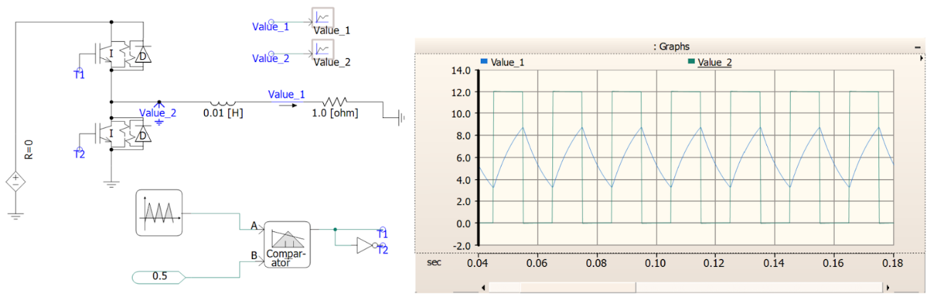

Fig 1. Half wave inverter with square PWM

* Connect DC Supply to the inverter.
* Use IGBT as switching devices.
* Add Freewheeling Diodes across IGBTs for protection.
* Implement PWM Controller to regulate IGBT switching.
* Generate Square Wave output by alternating IGBT switching.
* Filter Output if smoother waveform is needed.

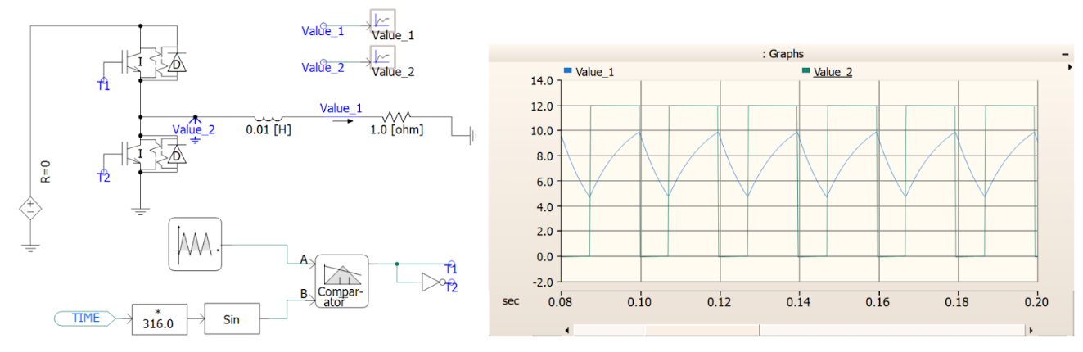

Fig 2. Half wave inverter with sine PWM

* Build the circuit: Connect DC source to IGBTs (T1&T2) with opposite polarities. Diodes (D) in parallel with each IGBT, facing opposite direction of DC source.
* Generate PWM signal: Use microcontroller to create a sine wave (reference) and a triangular carrier wave.
* Compare signals: Compare the sine wave with the carrier wave. When sine > carrier, turn on T1 (output positive). When sine < carrier, turn on T2 (output negative).
* Filter output: The switching generates a stepped waveform. Use a low pass filter to convert it to a cleaner sine wave output.

**2.3 Full Wave Inverter with PWM**

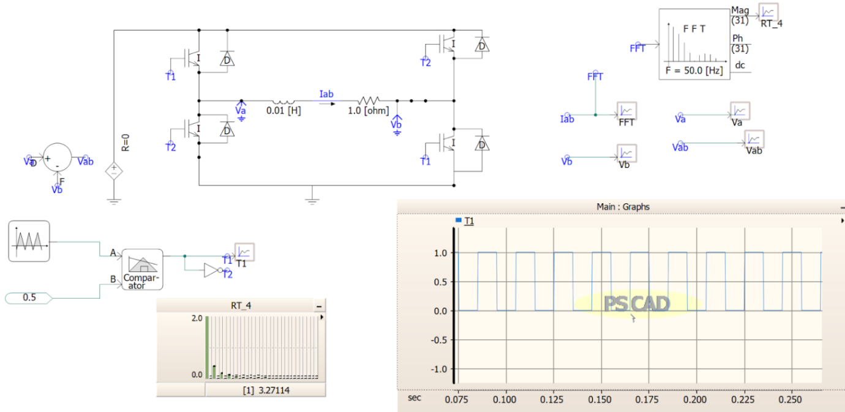

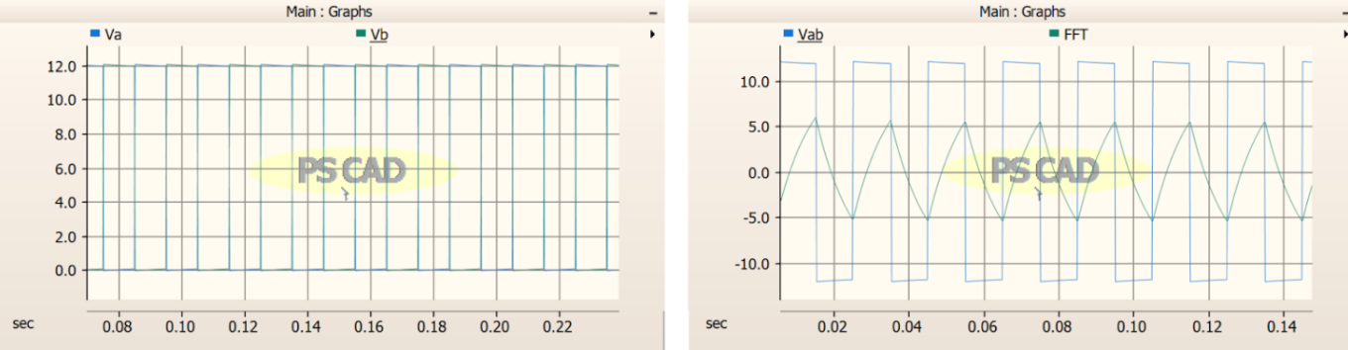

Fig 3. Full wave inverter with square PWM

* Build H-bridge: Connect DC source with 4 IGBTs (T1-T2) in an X pattern. Anti-parallel diodes (D) flank each IGBT.
* Generate & Compare: Microcontroller creates a sine wave and compares it to a high-frequency carrier wave.
* Switch Diagonals: Based on comparison, turn on opposite IGBTs (T1 &T2) creating positive/negative DC output.
* Filter (Optional): Low-pass filter smooths the rapidly switching output for a cleaner sine wave.

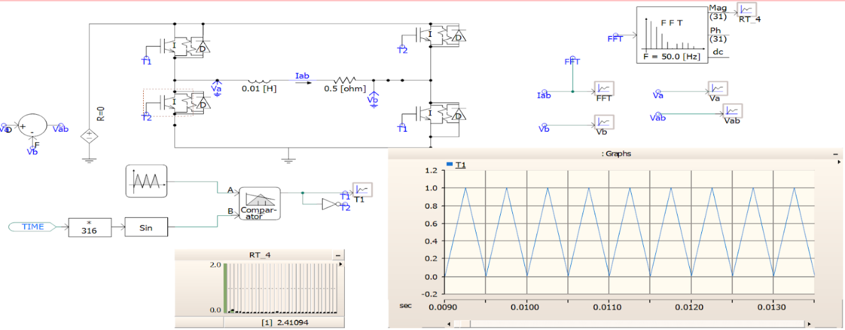

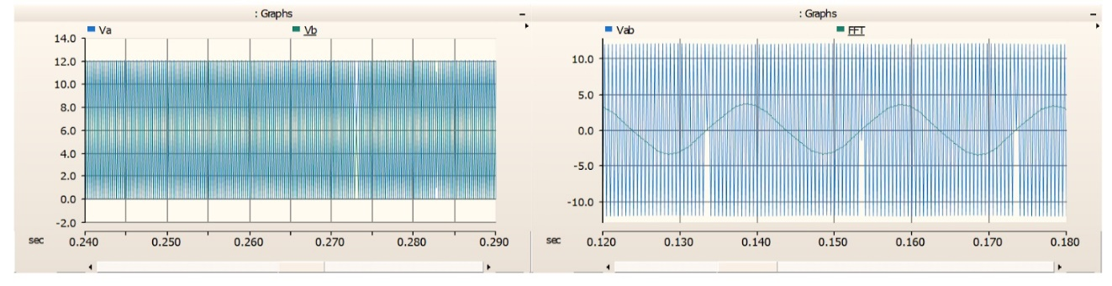

Fig 4. Full wave inverter with sine PWM

* Connect DC source to four IGBTs (T1-T2) in H-bridge. Anti-parallel diodes (D) for each.
* Generate square wave: Use a controller to create a high-frequency square wave signal.
* Switch IGBTs: Turn on T1, attached diagonally (T2) based on PWM signal. This connects + or - DC to output.
* Square wave output: Rapid switching creates a square wave AC voltage at desired frequency.

**Converter**

A converter circuit transforms electrical energy between different forms. It can change voltage (DC-DC, AC-DC, DC-AC), current, or frequency. Common converter types include buck (reduces voltage), boost (increases voltage), buck-boost (both increases and reduces voltage), and inverters (DC to AC). Converters are crucial in power electronics for powering various devices with the appropriate voltage and current.

**3.1 Phase Lock Loop (PLL)**

A PLL consists of three key components:

* **Phase detector** (also known as a phase comparator or mixer). It compares the phases of two signals, and generates a voltage according to the phase difference. It multiplies the reference input and the voltage-controlled oscillator output.
* **Voltage-controlled oscillator**. Generates a sinusoidal signal, whose frequency closely matches the centre frequency provided by the low-pass filter.
* **Low-pass filter**. A kind of loop filter that attenuates the high-frequency alternating current (AC) component of the input signal to smoothen and flatten the signal to make it more DC-like.

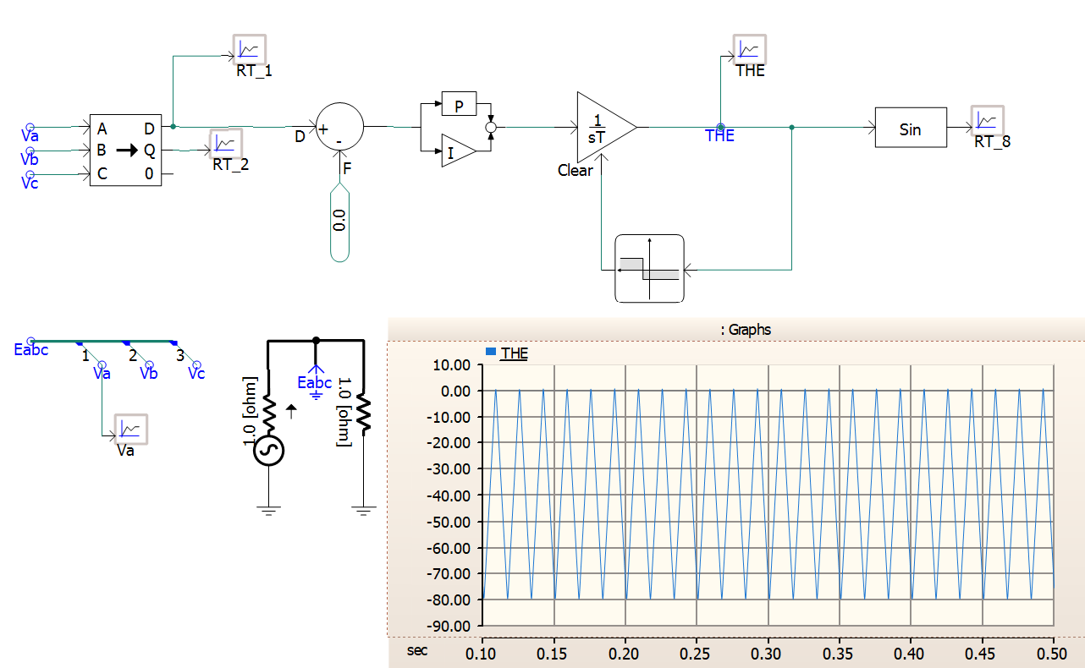

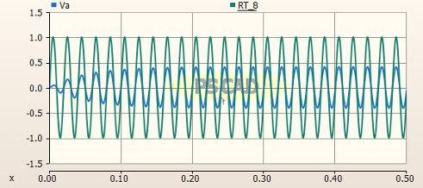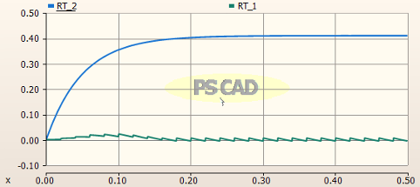

Fig 5. Phase-lock loop(PLL)

**3.2 PI Controller Tunning Method**

PI controller tuning aims to optimize its response for a specific system. There are two main approaches: Manual Tuning: This involves adjusting the proportional gain (Kp) and integral time (Ti) based on the system's response. Ziegler-Nichols method is a common technique, offering starting values based on the system's open-loop step response. Model-Based Tuning: This method requires a mathematical model of the system. Using software tools, you can calculate optimal Kp and Ti values for desired performance metrics like settling time and rise time.

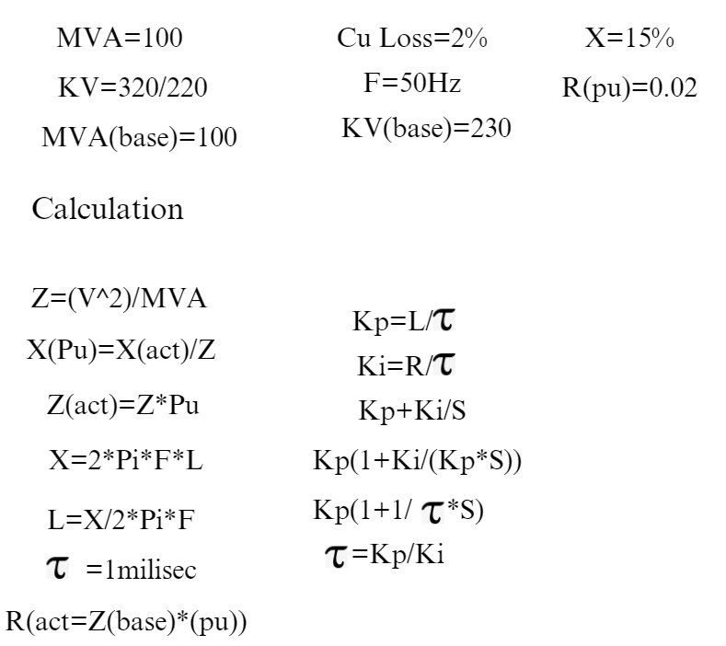

**3.3 Closed Loop Control of Three Phase Converter**

Closed-loop control of a three-phase converter involves using feedback mechanisms like phase-locked loops (PLL), pulse-width modulation (PWM), and proportional-integral (PI) controllers to regulate the output. This ensures stable and efficient conversion of electrical power by continuously adjusting the converter's operation based on real-time performance data.

1. With only one converter:

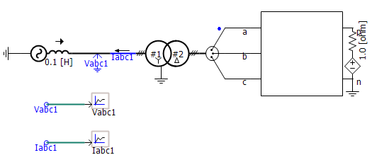 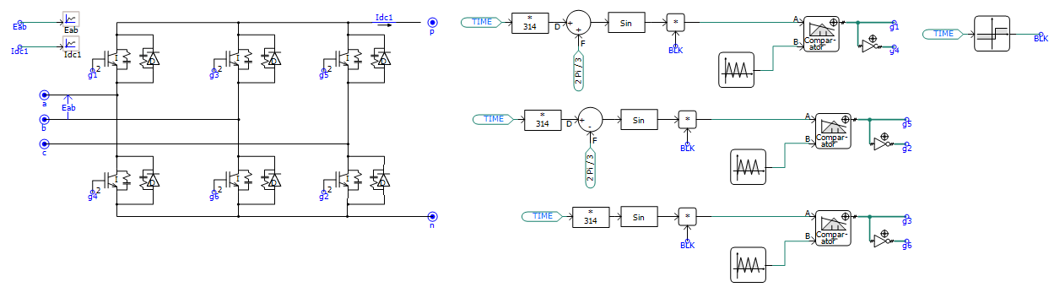

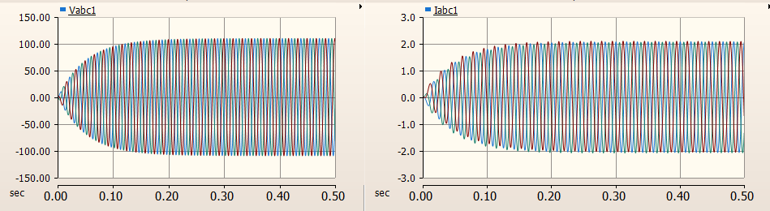

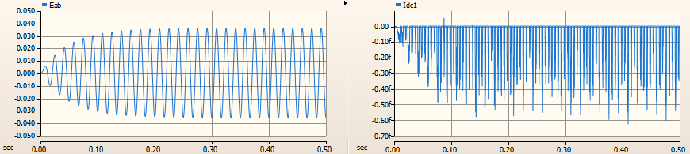

Fig 6. Single Converter

1. Pi-model: 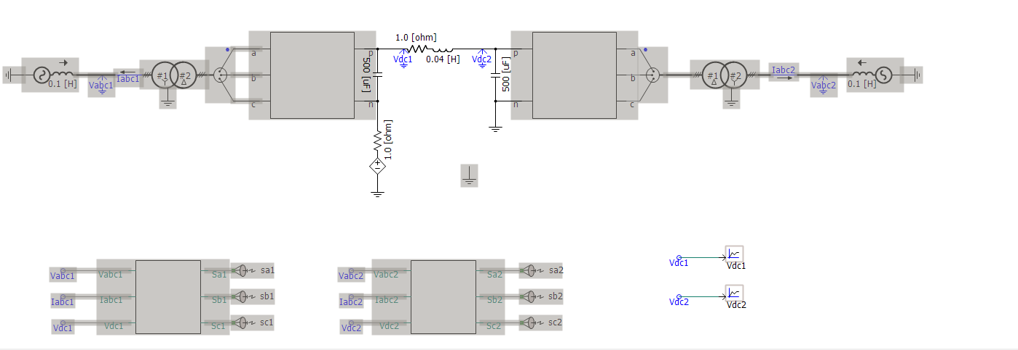

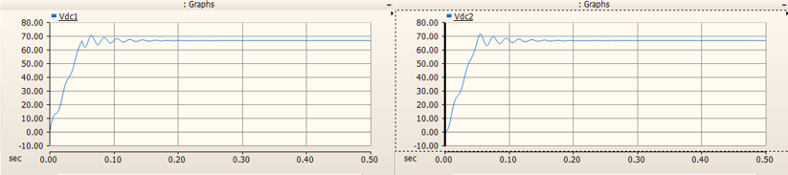

Fig 7. Converter pi model

1. Converter with Controller:

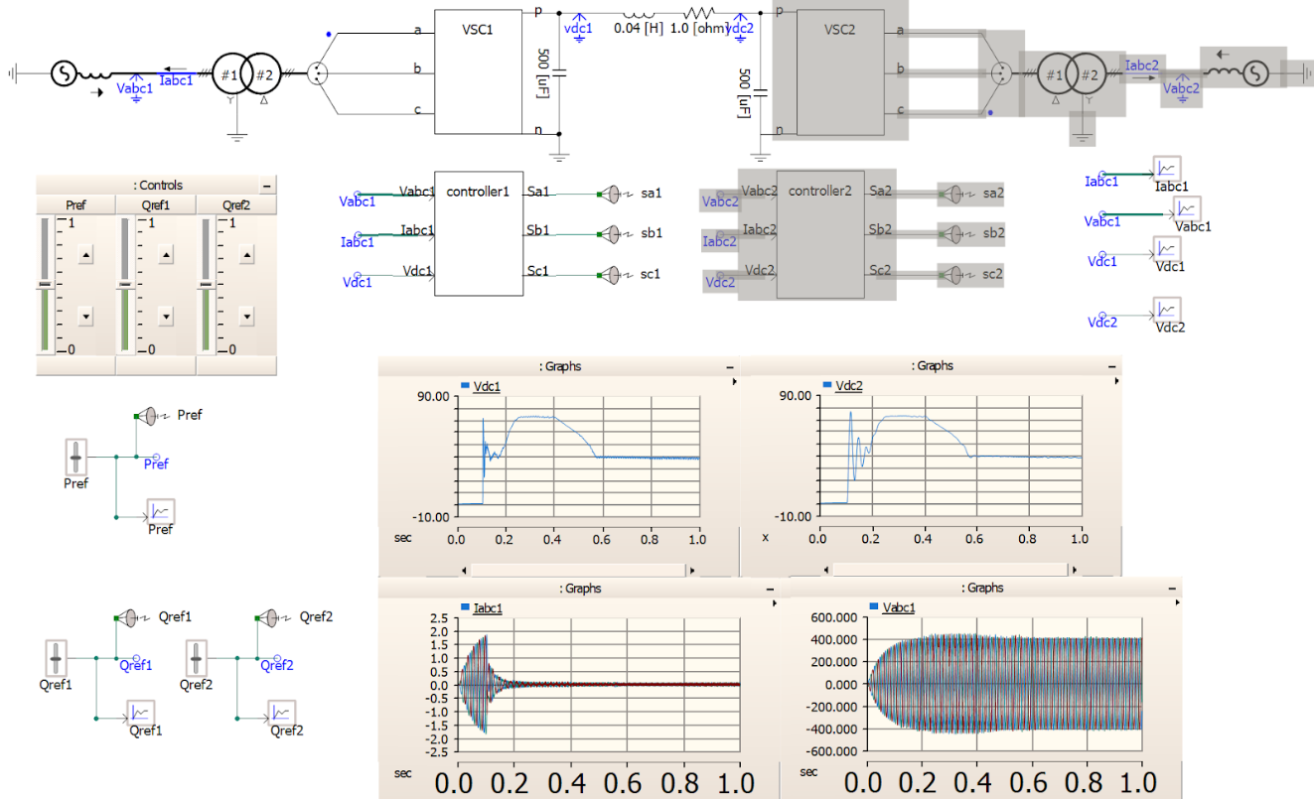

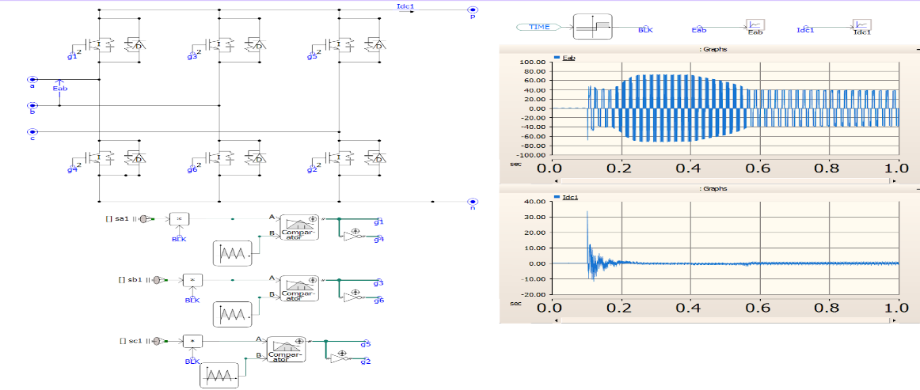

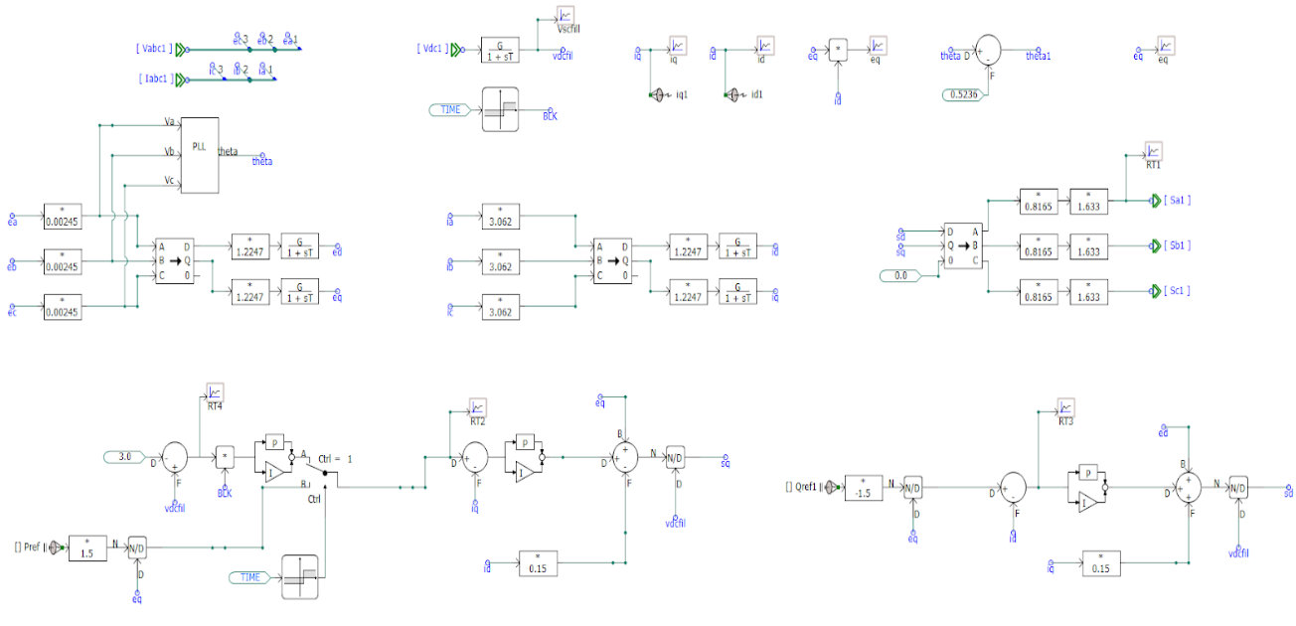

Fig 8. Single Converter with one Controller Applied

1. Controller with constant current source:

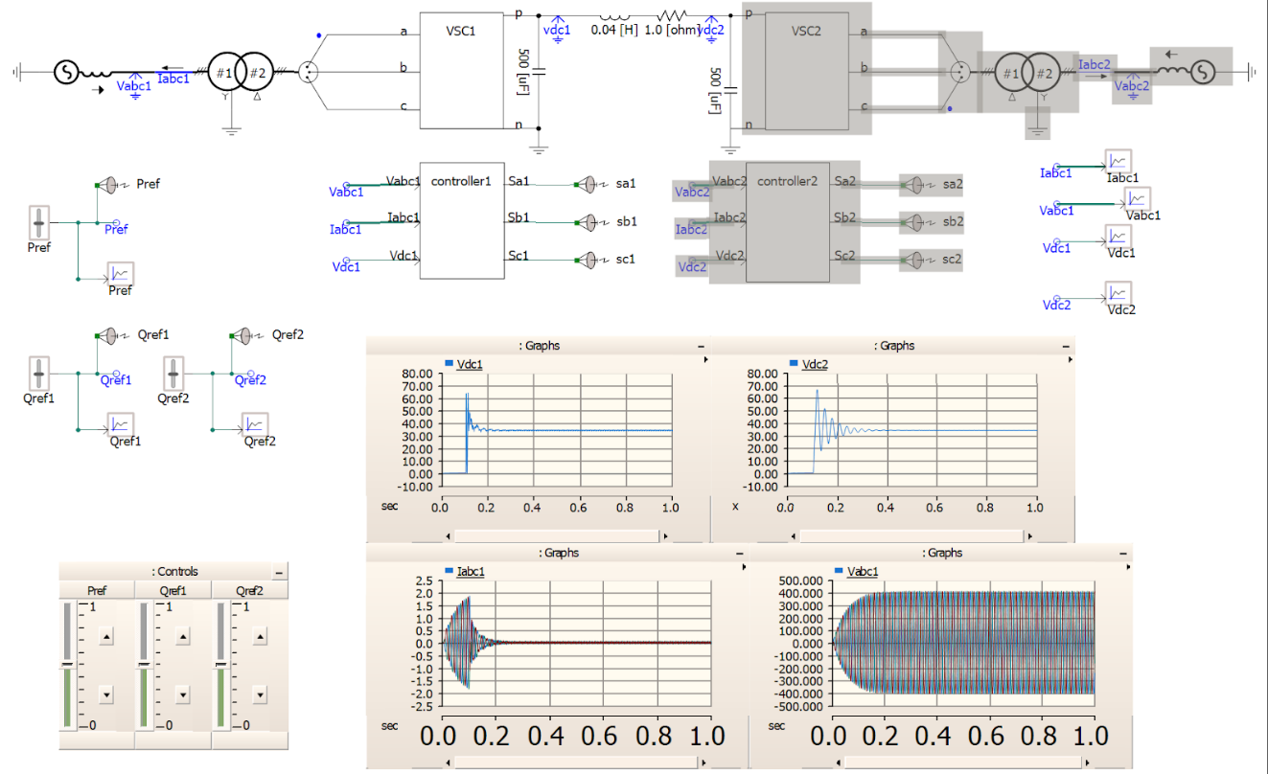

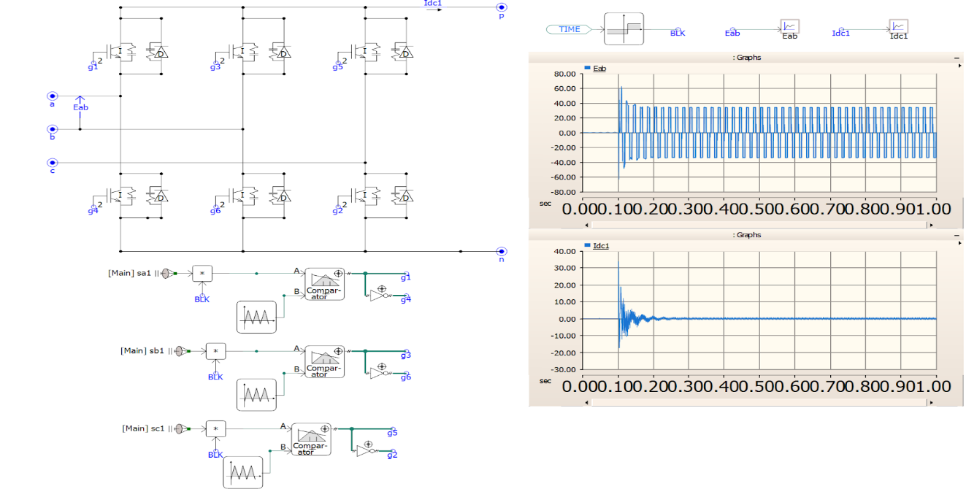

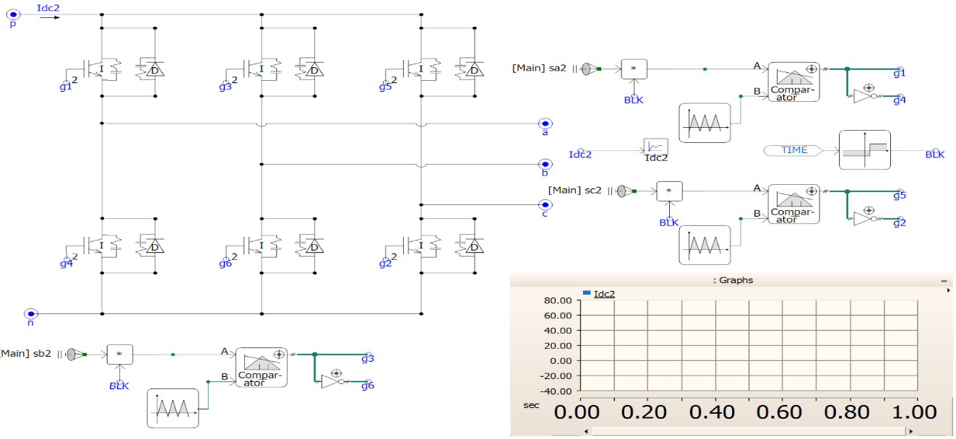

Fig 9. Controller with constant current source

1. Closed Loop Three Phase Converter:

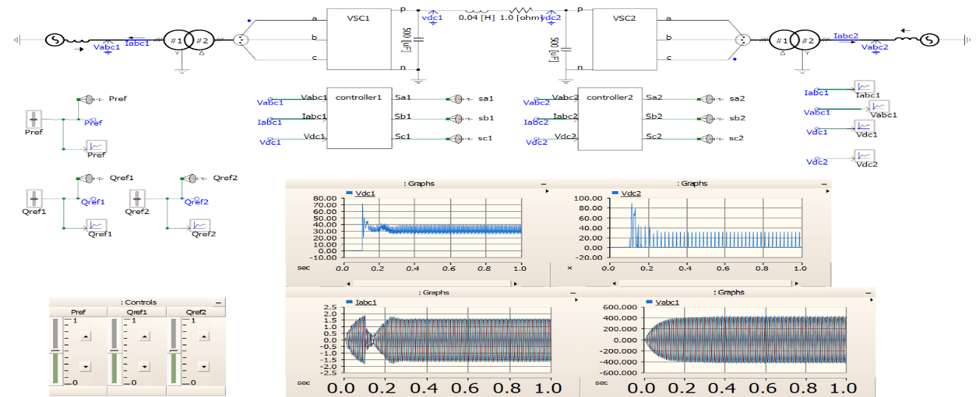

VSC1-

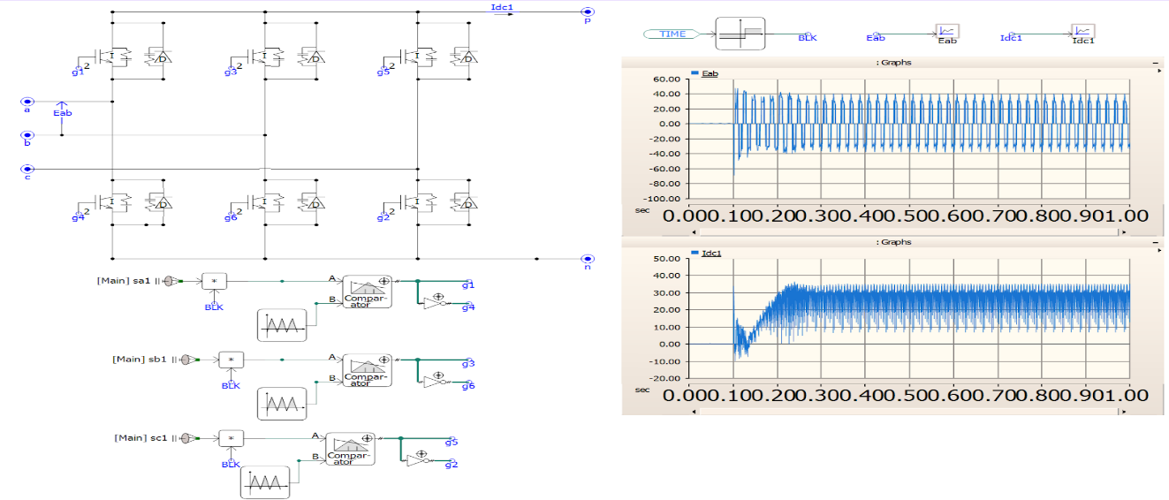

VSC2-

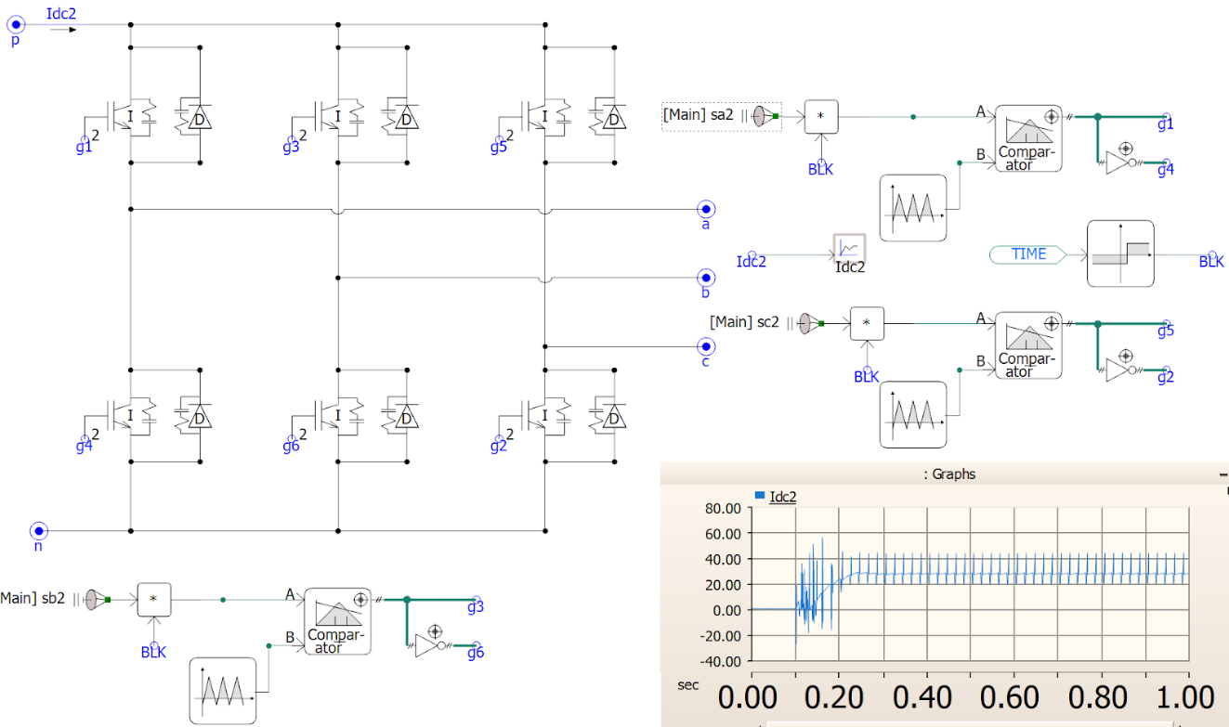

Controller1:

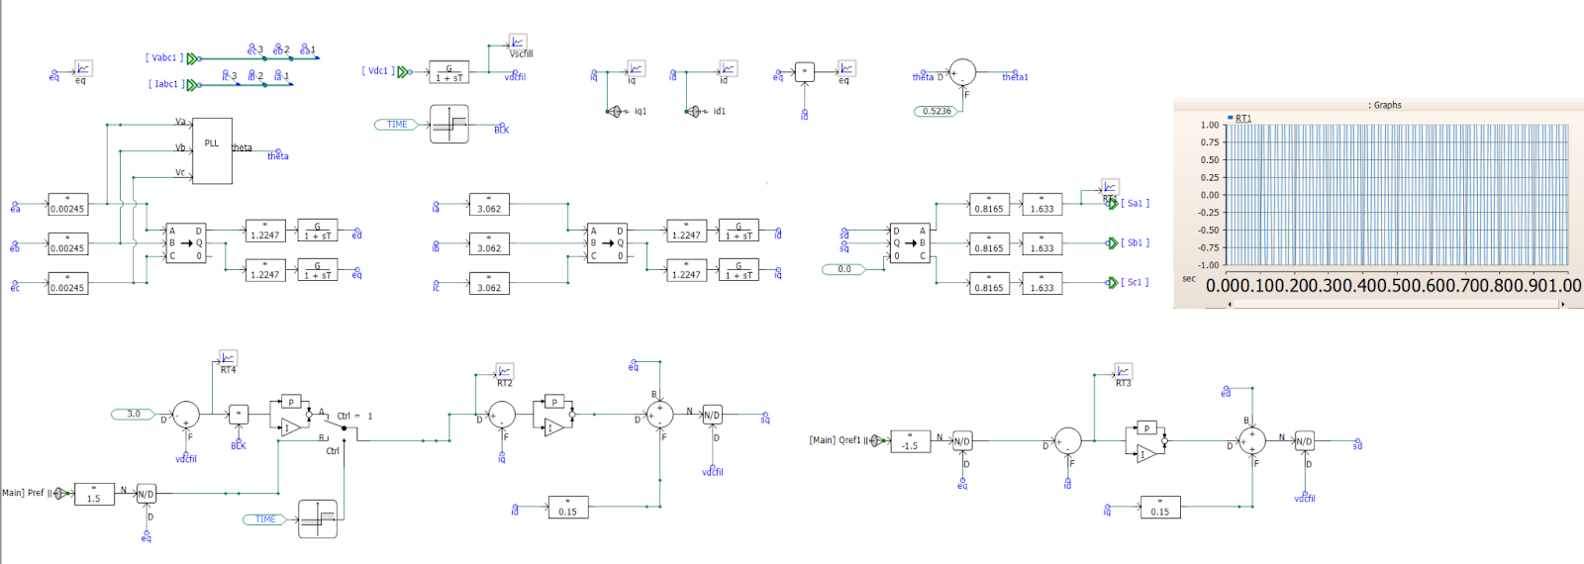

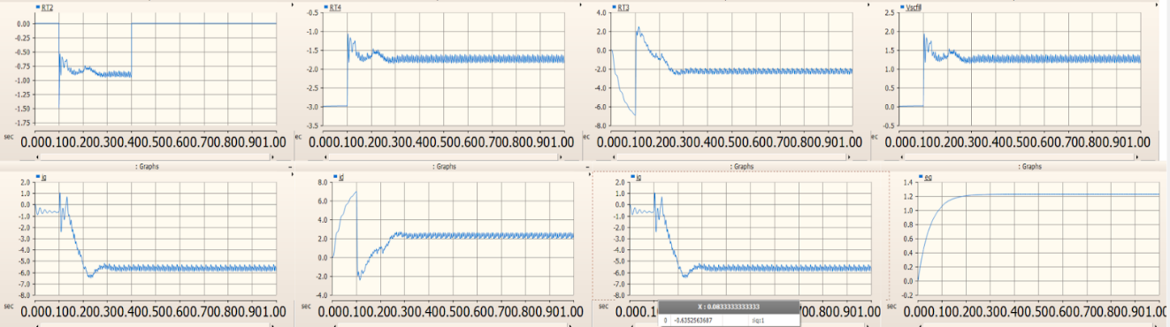

Controller2- 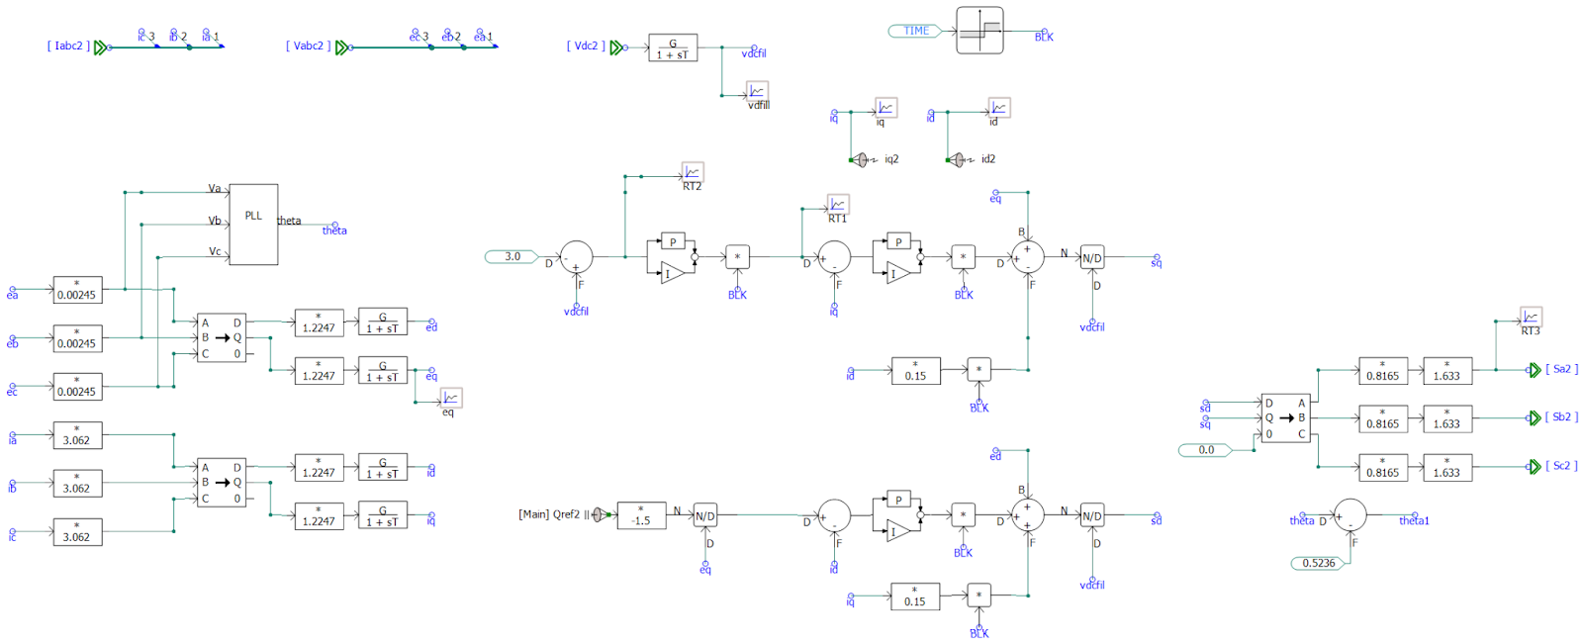

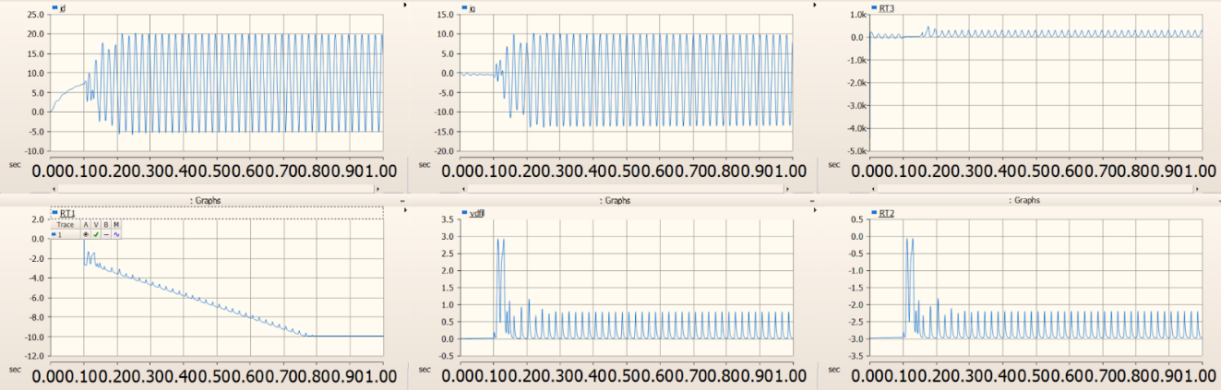

Fig 10. Three phase closed loop converter

**Transmission Line**

1. Transmission Line Model:

(a) Frequency Dependent Model

(b) Bergeron Model

(c) Coupled Pi Model

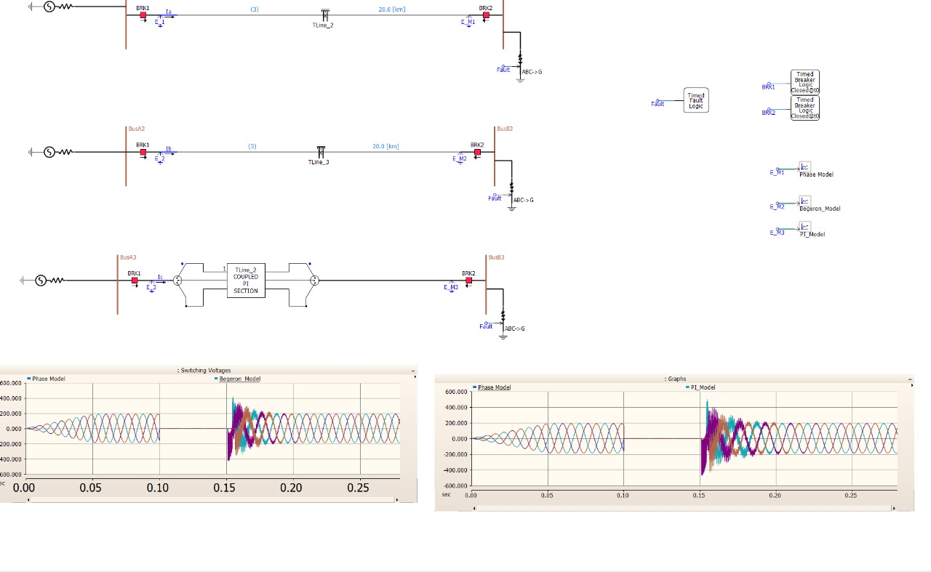

Fig 11. Transmission Line Model

1. Double circuit line with and without ideal Transportation:

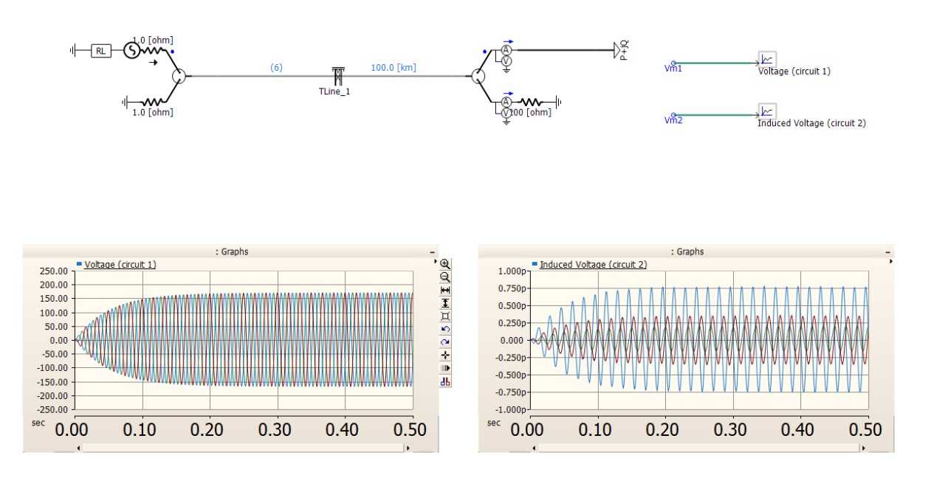

1. Using Mutual coupling Features:

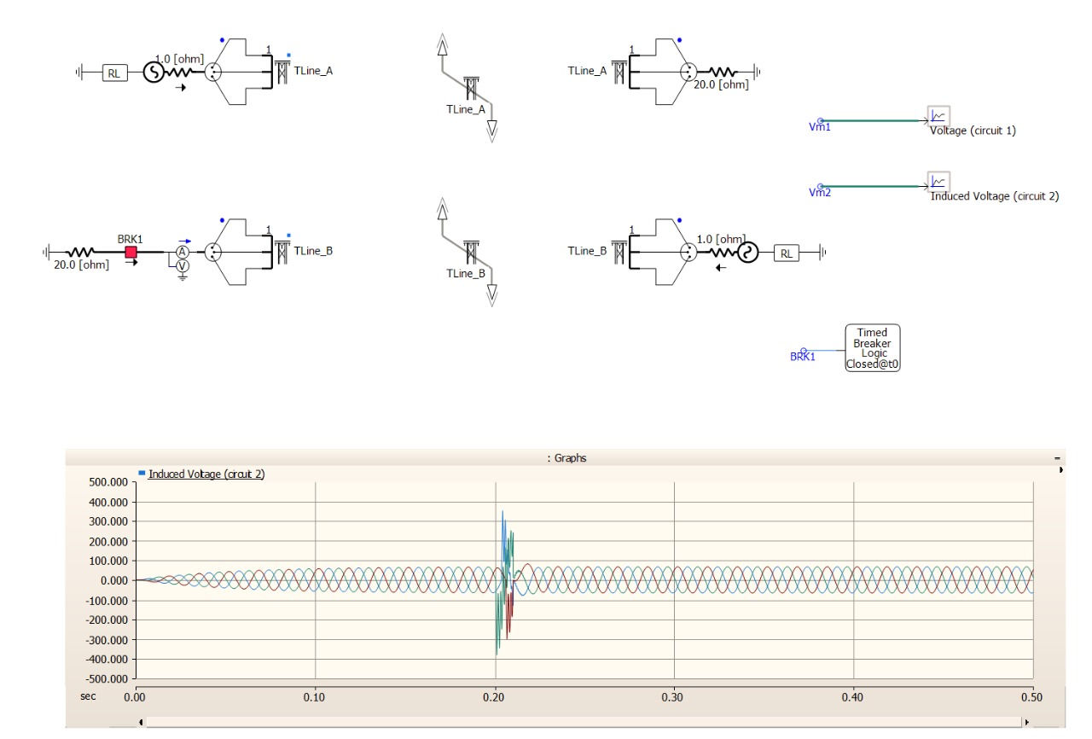

Fig 12. Transmission Line Model

**Conclusion**

During this research internship, various models of power electronic devices in transmission lines were designed and implemented. This report covers the development and analysis of inverter models, including half-bridge and full-bridge inverters, which are crucial for converting DC to AC power in applications such as renewable energy systems and uninterruptible power supplies.

A key project involved designing a three-phase converter with closed-loop control using phase-locked loop (PLL) technology, pulse-width modulation (PWM), and proportional-integral (PI) controllers. These components ensured stable and efficient power conversion and were vital in understanding advanced control mechanisms in power electronics.

The report also explores the modelling and analysis of various transmission lines, providing insights into the complexities of electrical power transmission and distribution. Extensive use of PSCAD for simulations and modelling was a critical aspect of this work, bridging the gap between theoretical knowledge and practical application.

Overall, the internship has significantly enhanced our understanding of power electronics in transmission lines, equipping us with essential skills and knowledge for future endeavours in this field. This experience underscored the importance of efficient design and precise control in power electronic systems, laying a solid foundation for continued research and professional development.

**References**

[1] Beerten, J., Cole, S., Belmans, R.: ‘Modeling of multi-terminal VSC HVDC systems with distributed DC voltage control’, IEEE Trans. Power Syst., 2014, 29, (1), pp. 34–42

[2] Prieto-Araujo, E., Bianchi, F.D., Junyent-Ferre, A., et al.: ‘Methodology for droop control dynamic analysis of multiterminal VSC-HVDC grids for offshore wind farms’, IEEE Trans. Power Deliv., 2011, 26, (4), pp. 2476–2485

[3] https://books.google.com/books?id=If_hxYcDnAUC&printsec=copyright

[4] Kundur, P.: ‘Power system stability and control’ (McGraw-Hill Inc., New York, 1993)

[5] <https://ieeexplore.ieee.org>

[6] <https://books.google.com/books/about/Power_System.html?id=KoFUJ5je-rUC>

[7] https://ieeexplore.ieee.org/document/8740645/